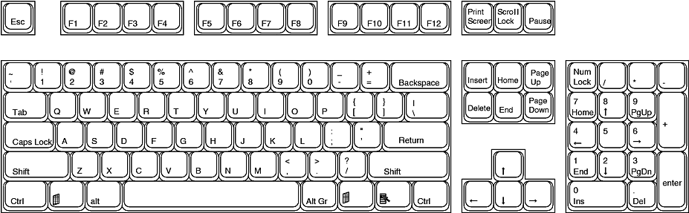
Keyboard Functions

Escape - Esc is used to back out of situations.
F1 - While working in an application, depressing this key will bring up the applications help menu.
If there is no open application F1 will open Windows Help.
F2 - Choose this key to rename a selected item.
F3 - Depressing this key will display the Find: All Files dialog box.
F4 - Holding down the Alt key while depressing F4 closes the current active window. If there is no active window this opens the Shut Down dialog box.
F5 - Select this key to refresh the contents of a dialog box, such as the Save As or Open dialog boxes, or in a window such as a Windows Explorer window.
F6 - F6 + Ctrl to move to a previous window if you have multiple documents open in MS Word
F7 - Perform Spell and Grammar check in MS Word
F10 - Activates Menu Bar options. Use right and left arrows to select menus and down arrows to display pull down menus.
F11 - In Internet Explorer this key will allow you to toggle back and forth between full screen view and normal view
each time you tap F11 in word a new worksheet is added.
F12 - Open a new document in MS Word
Print Screen- This sends a copy of whatever is on the screen to the clipboard.

